Minutes - Fieldstone Farms HOA Board Meeting
Date | August 21, 2025
Time | 6:00 p.m.
LOCATION | Bob Kirby Branch Warren County Public Library  175 Iron Skillet Drive, Bowling Green, KY 42104



In attendance
Wanda Weidemann, Bob Aspley, Donna Aspley, Barbara Davis, Deborah Dearing-Yoakem, David M. Dearing, and Sonja Griffith.

CALL TO ORDER
The meeting was called to order by Bob Aspley, HOA President, at 6:00 p.m. He welcomed all attendees to the meeting.

Presentation from AT&T Fiber
HOA President Bob Aspley Introduced Chris and Lyndsey from AT&T. AT&T Fiber is now available in our neighborhood. You can call or go by the local AT&T store on Campbell Lane to get help with new fiber service. Their purpose in meeting with us today was to ascertain if it would be possible to set up a table and sign somewhere in the neighborhood to let potential customers know that it is available in our neighborhood and come to them for information and enrollment. It was suggested that a potential date for this would be the same day as the neighborhood yard sale which is scheduled for September 20th, 2025. Barbara Davis indicated to the representatives that she would be willing to allow them to use her side corner yard bordering on Fieldstone Boulevard.

Approval of minutes
Copies of the minutes from May 15th, 2025, meeting were sent to all Officers and Board Members by email on May 20th, 2025. Paper copies of the minutes were available at the meeting for all, and the reading of the minutes was not done because all attendees already read them. Barbara Davis made a motion to approve the minutes as written and read. David M. Dearing seconded the motion. Bob Aspley called for the vote--unanimous. Minutes approved.

TREASURERS REPORT
Wanda Weidemann provided a written copy of the Treasurer's Report to all attendees.
Wanda Weidemann stated that the savings account had been changed to a basic checking account with no fees—it does not pay any interest, but the account should come out ahead since the fees were higher than the interest earned with the savings account. Donna Aspley made a motion to approve the Treasurer’s report as presented. Barbara Davis seconded. Bob Aspley called for the vote--unanimous. Treasurer’s Report approved.

Page 2

COMMITTEE REPORTS
- Architectural and Design Report – Deborah Dearing-Yoakem noted that the property owner on Fieldridge has painted the roof on his covered patio structure to comply with the HOA requirements. Sonja Griffith noted that she had noticed that a homeowner at 3371 Innsbrook has used an old tire around a young tree and inquired as to if this is an architectural or design element; or, if it is just a CCR violation. Discussion was held by all in attendance, and Sonja Griffith made a motion saying -Old tires should not be an acceptable design element in landscaping for the neighborhood. More discussion held, no second to motion. It was decided that Bowling Green City Code Enforcement be contacted and see if they will allow this as it was noted by David M. Dearing and Deborah Dearing Yoakem that Code Enforcement does not allow old tires to reside in driveways, porches, or carports—they make you to remove them.
- Landscape Committee Report –Wanda Weidemann reminded everyone that we now use Southern Touch Lawn and Landscape for 2025. It was noted that we have paid them 4 payments of $1,369.00 for mowing. The PVA office for Warren County has assessed the retention basin property owned by the HOA at a value of $1,000.00.
- Enforcement Committee/Neighborhood Watch – Sonja Griffith reported that ten (10) letters have been sent since last meeting. In August, two (2) letters have been sent from Alice Williams (property/hoa management) for overnight parking and for a semi being parked in a driveway in the neighborhood.
- Social Committee – Donna Aspley noted the fall yard sale held on Saturday September 20th, 2025.
- Website – Sonja Griffith reported that we have paid through May 2026 to have a website for our neighborhood. Sonja Griffith has been exploring other means of getting information available to all residents of the neighborhood via the internet. She has been exploring means to track the number of users on the website. Our neighborhood currently has a Facebook page and are considering a way to get the minutes of HOA meetings available on this page. Also, maybe making a way for users to send problems directly to Alice Williams (property/hoa management). Wanda Weidemann has offered to see if the technology personnel where she works could give us some insight to achieving this.

NEW BUSINESS
The presentation from AT&T as outlined above. No other new business discussed.

Next meeting
The next quarterly meeting will be on the third Thursday of the month, on November 20th, 2025, at 6:00 p.m. at the Bob Kirby Branch of the Warren County Public Library, 175 Iron Skillet Drive, Bowling Green, KY 42104. It was noted that Officer Elections are usually held at this meeting.

ADJOURNMENT
Barbara Davis made a motion to adjourn the meeting; seconded by Wanda Weidemann. Accepted, Motion carried.

Page 3
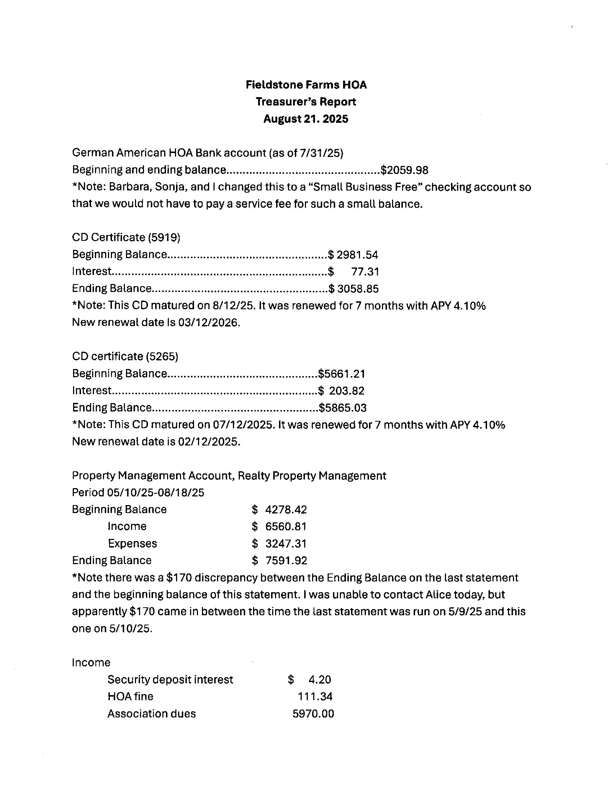

Page 4
