Minutes - Fieldstone Farms HOA Board Meeting
Date | February 20, 2025
Time | 6:00 p.m.
LOCATION | Bob Kirby Branch Warren County Public Library  175 Iron Skillet Drive, Bowling Green, KY 42104



In attendance
Wanda Weidemann, Bob Aspley, Donna Aspley, Barbara Davis, Kelia Ballou, Deborah Dearing-Yoakem, Mike Lawrence, and Sonja Griffith.

CALL TO ORDER
The meeting was called to order by Bob Aspley, HOA President, at 6:00 p.m. He welcomed all attendees to the meeting.

Approval of minutes
Copies of the minutes from the November 21st, 2024, Annual Meeting were sent to all Officers and Board Members on December 9th, 2024. The minutes were read aloud by Deborah Dearing-Yoakem to the attendees. Barbara Davis made a motion to approve the minutes as written and read. Wanda Weidemann seconded the motion. Bob Aspley called for the vote-unanimous. Minutes approved.

TREASURERS REPORT
Wanda Weidemann provided a written copy of the Treasurer's Report to the attendees.

Donna Aspley made a motion to approve the Treasurer’s report as presented. Mike Lawrence seconded. Bob Aspley called for the vote-unanimous. Treasurer’s Report approved.

Discussion was held on the following topics generated by the Treasurer’s Report:
- A bill for $135 to Attorney Julie Shadoan has not cleared the Property Management account so that balance will change.
- There is a homeowner in bankruptcy, but this will not cost us any money as the homeowner does not owe back HOA payments
- There is a need to add additional money to the Property Management Account. It was discussed by attendees that the yearly $25 HOA payment, per property, needs to be raised. It was expressed that if we do not, it may be necessary to cash in one of the CD’s to continue to fund the Property Management Account. If the HOA yearly payment needs to be raised, it would be necessary to decide as the bills are sent out in the month of April and are due in the month of May. It was also noted that a letter needs to be included in the yearly billing explaining the need for the HOA payments to increase.

Page 2

Barbara Davis made a motion to increase the HOA payment by $10 yearly ($35 per year). No one seconded and more discussion was held as to whether this amount of increase would be enough to cover expenses. Wanda Weidemann made a motion to raise the yearly payment $15 which would make the yearly HOA payment $40 per property. Mike Lawrence seconded the motion. Bob Aspley called for the vote-7 yes, 1 opposed. Motion carried.

COMMITTEE REPORTS
- Architectural and Design Report – Deborah Dearing-Yoakem noted that the property owner on Fieldridge has started painting his covered patio structure to comply with the HOA requirements. Wanda Weidemann noted that when the weather improves the homeowner intends to paint the roof to further comply. Mike Lawrence brought to our attention that a property owner on Cave Springs (Stephanie L., Danny, & Tammy Thompson,3815 Cave Springs Ave.) has erected a type of structure behind the house that is not on their property. Bob Aspley knows the family of the property owner, Billy J. Bell, and he will contact them concerning the Cave Springs property owners’ trespass onto Mr. Bell’s property.

- Landscape Committee Report –Wanda Weidemann has been getting estimates/bids on the landscaping around the main entrance circle and entrance posts and the mowing/maintaining of the Wheatstone retention basin. Two estimates were received. One from Perennial Lawn Care owned by Ray Santos who currently is who the HOA has contracted with in past years. The total of his bid for all services is $4.310.00 for the year 2025. The second bid was from Southern Touch Lawn and Landscape. The total of his bid for all services was $4,107.50. Discussion was held by all in attendance and Mike Lawrence made a motion to accept the bid from Southern Touch, seconded by Bob Aspley. Bob Aspley called for a vote-unanimous. Motion carried to use Southern Touch Lawn and Landscape for 2025.
Also, Wanda Weidemann reported that Ray Santos had previously been asked to repair the retention basin fence around the Wheatstone retention basin. Mr. Santos gave a verbal estimate of $75 an hour plus the price of the post to fix the fence. It is her understanding that he has already purchased the post, and he indicated that it would take two (2) hours to install/repair. Sonja Griffith made a motion to write a letter to Ray Santos to pay him $225 to fix the fence and install the post and also to put a date of completion on the work to be done of April 15th, 2025 and if the work is not completed by that date, he3 forfeits the opportunity to fix. Mike Lawrence seconded the motion. Bob Aspley called for the vote-unanimous. Motion carried.

- Enforcement Committee/Neighborhood Watch – It was reported that two (2) wagons are in driveways/yards on Cave Springs. One wagon has been there for weeks. It was suggested that a letter be sent to address this issue. Also, it was noted that parking in the yard space and on sidewalks is a violation of the city ordinance and parking on the street overnight is regulated by the HOA.

- Social Committee – Donna Aspley noted the spring yard sale held on Saturday May 17th, 2025.

- Website – Sonja Griffith reported that we pay $476 per year to have a website for our neighborhood, and we are paid up till 2026. Some discussion was held on this cost and if a cheaper method of having a website could be found. Sonja Griffith will explore costs and if we find a cheaper source, if monies already paid could be refunded.

NEW BUSINESS
Barbara Davis has been doing research on liability insurance to cover HOA board members. She has talked with Cruz, Houchens Insurance and they researched four (4) companies and Auto Owners was the cheapest good coverage.
The coverage for 379 Homeowners is annually $1,996.30 and paid in one payment reduces to $1,785.00; for 250 homeowners (up to date $25 homeowners’ payment) is annually $1,487.00 and paid in one payment reduces to $1,338.67. After discussion, it was decided to table the discussion for this meeting and do more research and return to this at the next meeting.
Page 3

Bob Aspley suggested that NO TRESPASSING signs be erected in and around the Wheatstone Retention basin. A sign could be put on the existing fence on the Cave Springs side of the retention basin. Deborah Dearing-Yoakem indicated that she knew someone in the subdivision that might donate metal posts for the signs erected. Mike Lawrence made a motion to install, at least, three (3) NO TRESPASSING signs. The motion was seconded by Sonja Griffith. Bob Aspley called for the vote-unanimous. Motion carried.

Next meeting
The next meeting will be on the third Thursday of the month, on May 15th, 2025, at 6:00 p.m. at the Bob Kirby Branch of the Warren County Public Library, 175 Iron Skillet Drive, Bowling Green, KY 42104.

ADJOURNMENT
Wanda Weidemann made a motion to adjourn the meeting; seconded by Bob Aspley. Accepted, Motion carried.

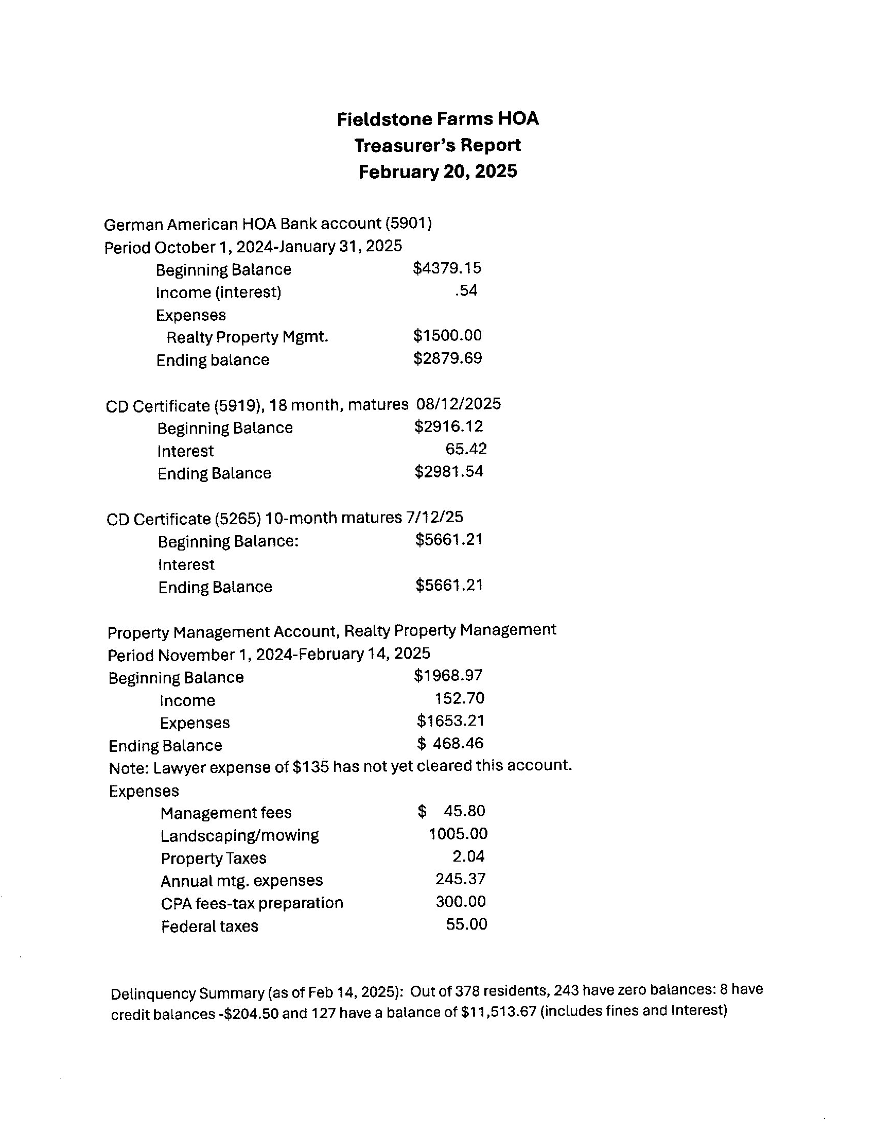
Page 4

